Name : Dev Adnani  
SID : 202212012

Subject : Systems Programming

Assignment : 7

Q1

202212012_Lab7_1_child.c

#include <stdio.h>

#include <stdlib.h>

int main(int argc, char *argv[])

{

FILE *fp;

char msg[100];

fp = fopen(argv[1], "r");

for (int i = 0; i < atoi(argv[2]); i++)

{

fgets(msg, 100, fp);

}

printf("%s", msg);

fclose(fp);

return 0;

}

202212012_Lab6_1_expo_parent.c

#include <stdio.h>

#include <stdlib.h>

#include <sys/wait.h>

#include <unistd.h>

int main(int argc, char *argv[])

{

if (argc < 3)

{

printf("Please provide argumenrs...\n");

exit(1);

}

int fd[2], status;

char msg[100];

if (fork() == 0)

{

close(fd[0]);

dup2(fd[1], 1);

close(fd[1]);

execl("./202212012_Lab7_1_child.out", "./202212012_Lab7_1_child.out", argv[1], argv[2], NULL);

}

else // parent

{

close(fd[1]);

read(fd[0], msg, 100);

printf("%s\n", msg);

wait(&status);

close(fd[0]);

}

return 0;

}

Screenshots :

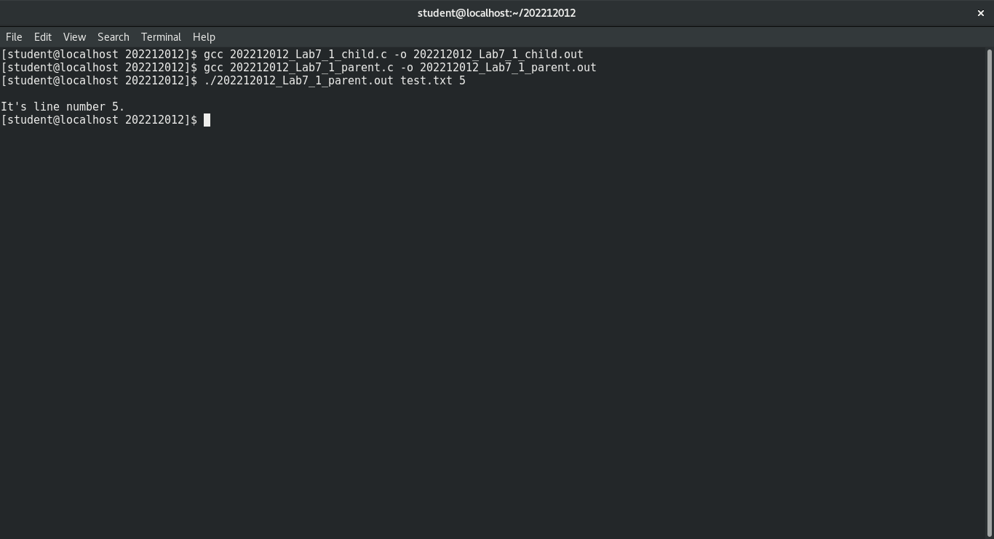

2:

202212012_Lab7_2.c

#include <stdio.h>

#include <stdlib.h>

#include <sys/wait.h>

#include <unistd.h>

int main(int argc, char *argv[])

{

if (argc < 3)

{

printf("Please provide argumenrs...\n");

exit(1);

}

int fd[2], status;

char msg[100];

if (fork() == 0)

{

close(fd[0]);

dup2(fd[1], 1);

close(fd[1]);

execl("./202212012_Lab7_1_child.out", "./202212012_Lab7_1_child.out", argv[1], argv[2], NULL);

}

else // parent

{

close(fd[1]);

read(fd[0], msg, 100);

printf("%s\n", msg);

wait(&status);

close(fd[0]);

}

return 0;

}

Output :

